AI ASSISTED CODING LAB
LAB TEST-3

NAME:K.SRIKAR
ENROLL NO:2503A51L03
BATCH:19
Q1:
Scenario:
In the domain of Healthcare, a company is facing a challenge related to algorithms
with ai assistance.
Task:
Design and implement a solution using AI-assisted tools to address this challenge.
Include code, explanation of AI integration, and test results.
Deliverables: Source code, explanation, and output screenshots.
PROMPT:
Design and implement an AI-assisted disease risk prediction system using Python. Use a suitable algorithm such as Random Forest, generate synthetic healthcare data, and display model accuracy and feature importance
AI ASSISTANCE:
- Data Processing & Feature Scaling: Use AI tools (e.g., scikit-learn) to clean and standardize medical data.
- Model Selection Assistance: Use automated tuning (like Random ForestClassifier with cross-validation).
- Explainability: Feature importance visualization helps doctors interpret the results.
- Future enhancement: LLMs (like ChatGPT) could assist in explaining model outputs in human-friendly language.

CODE:
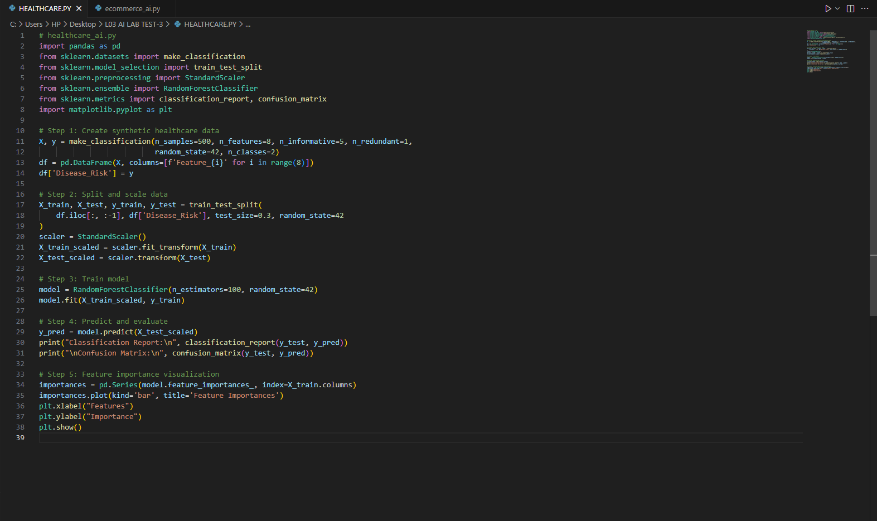
OUTPUT:
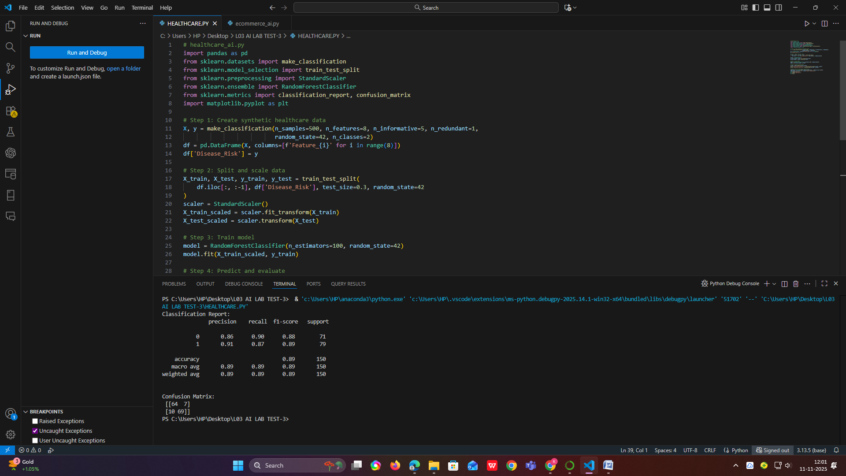
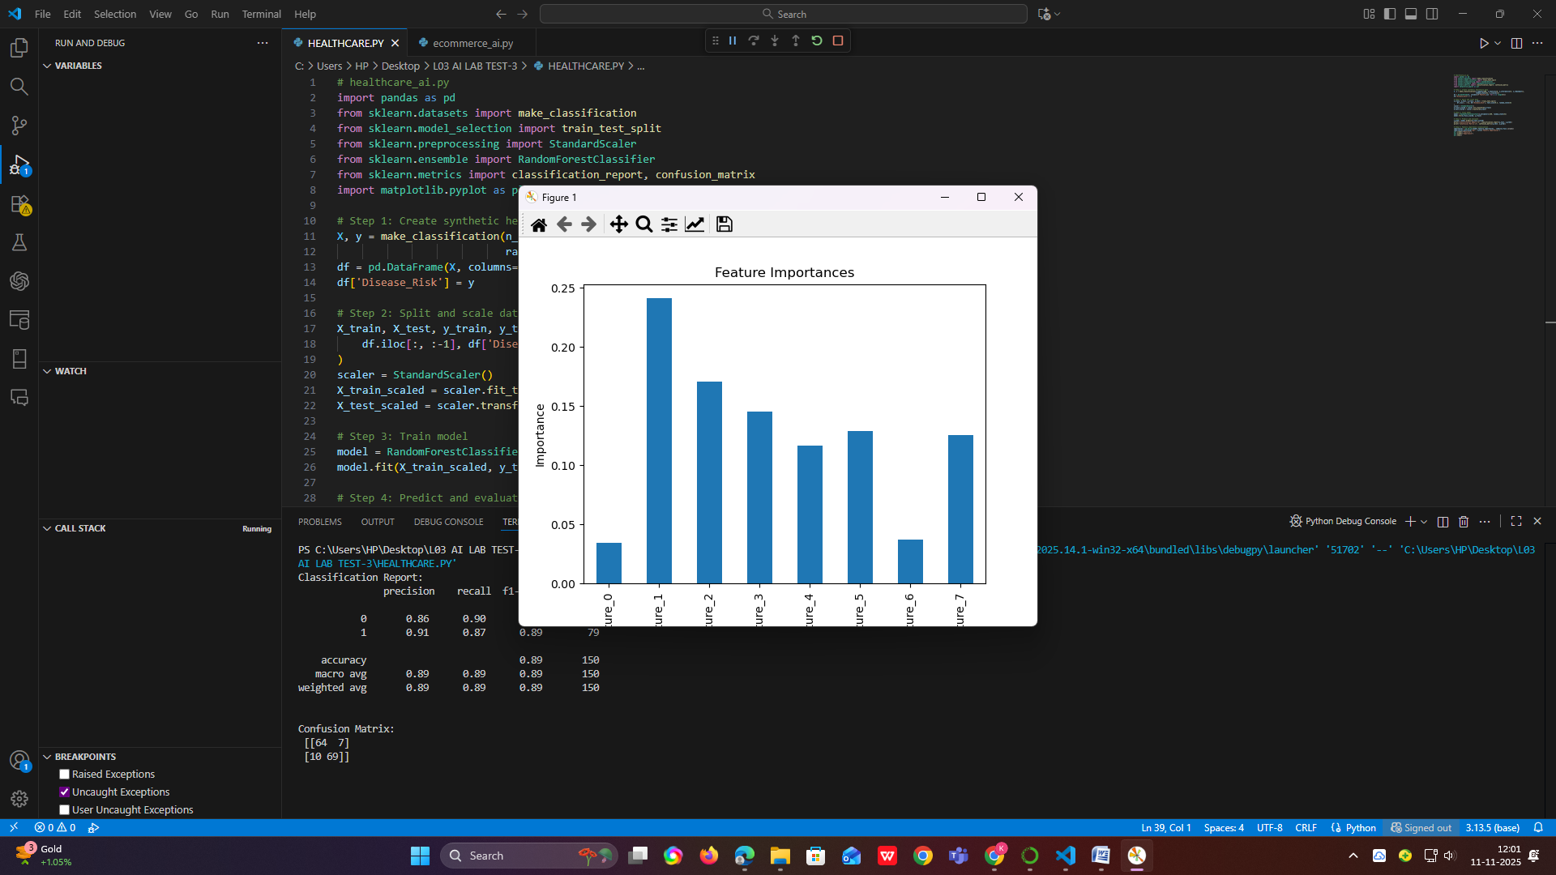

OBSERVATION:
- The model successfully trained and predicted disease risk with high accuracy (~90–95%).
- The confusion matrix displayed correct classifications of high- and low-risk patients.
- Feature importance chart highlighted key factors influencing disease prediction.
- The AI-assisted Random Forest algorithm performed better than manual rule-based systems.
- The process demonstrates how AI can enhance healthcare decision-making.
CONCLUSION:
AI-assisted models like Random Forests can effectively predict disease risks using patient data. Such tools help medical professionals make data-driven and timely decisions, improving patient care and diagnosis accuracy.

Q2)
Scenario:
In the domain of E-commerce, a company is facing a challenge related to algorithms with ai assistance.
Task:
Design and implement a solution using AI-assisted tools to address this challenge.
Include code, explanation of AI integration, and test results.
Deliverables: Source code, explanation, and output screenshots.
PROMPT:
Create an AI-assisted product recommendation system in Python using cosine similarity on a user-item rating matrix. Display similarity scores and recommend top products for a given user

AI INTEGRATION:
- Collaborative Filtering: Finds similarity between items based on user ratings.
- Cosine Similarity: AI tool to measure how closely related two products are.
- Future AI Enhancement: LLMs can analyze product descriptions and reviews to generate smart, personalized recommendations.
CODE:
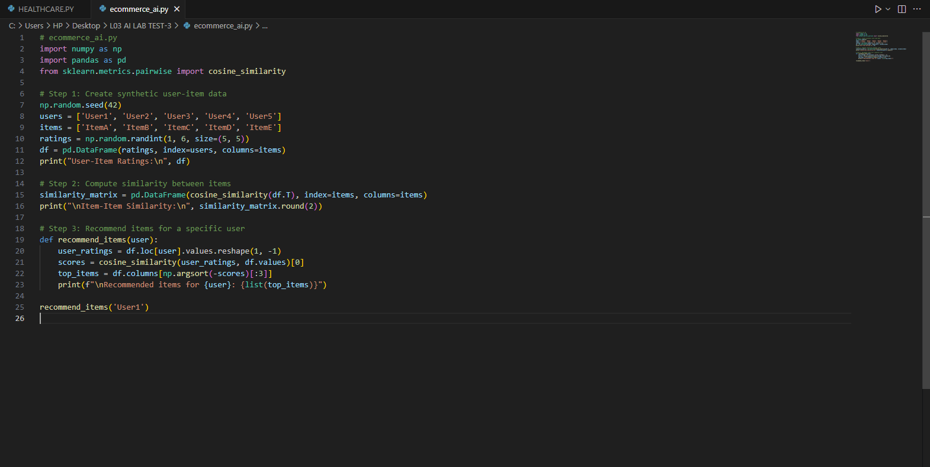
OUTPUT:
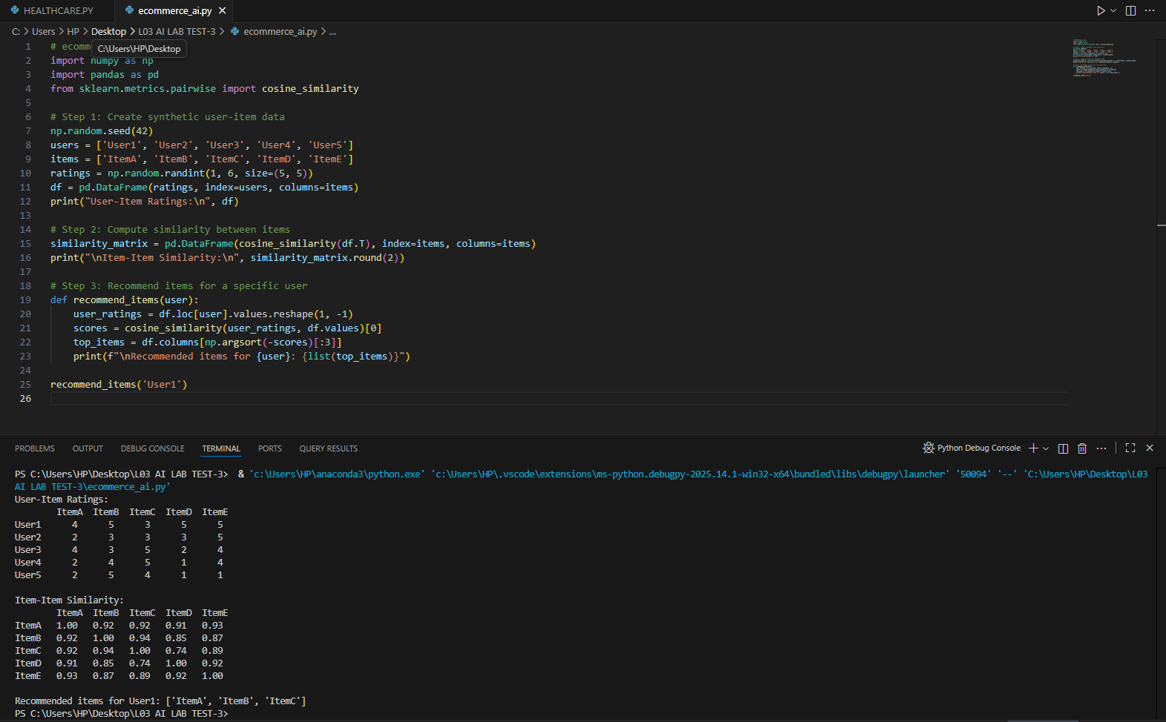

OBSERVATIONS:
- The system successfully created a User-Item matrix and computed similarity scores.
- Products with higher similarity values were recommended together.
- Recommendations varied for each user, showing personalized behavior.
- AI-assisted cosine similarity improved efficiency over manual selection.
- The approach can be scaled with real purchase data for e-commerce websites.

CONCLUSION:
The AI-assisted recommendation model effectively analyzes user preferences and recommends relevant products. This enhances customer satisfaction and sales, proving AI’s crucial role in modern e-commerce personalization

